**Objective:-** Deploy any simple React app on Firebase.

**Steps :-**

1. 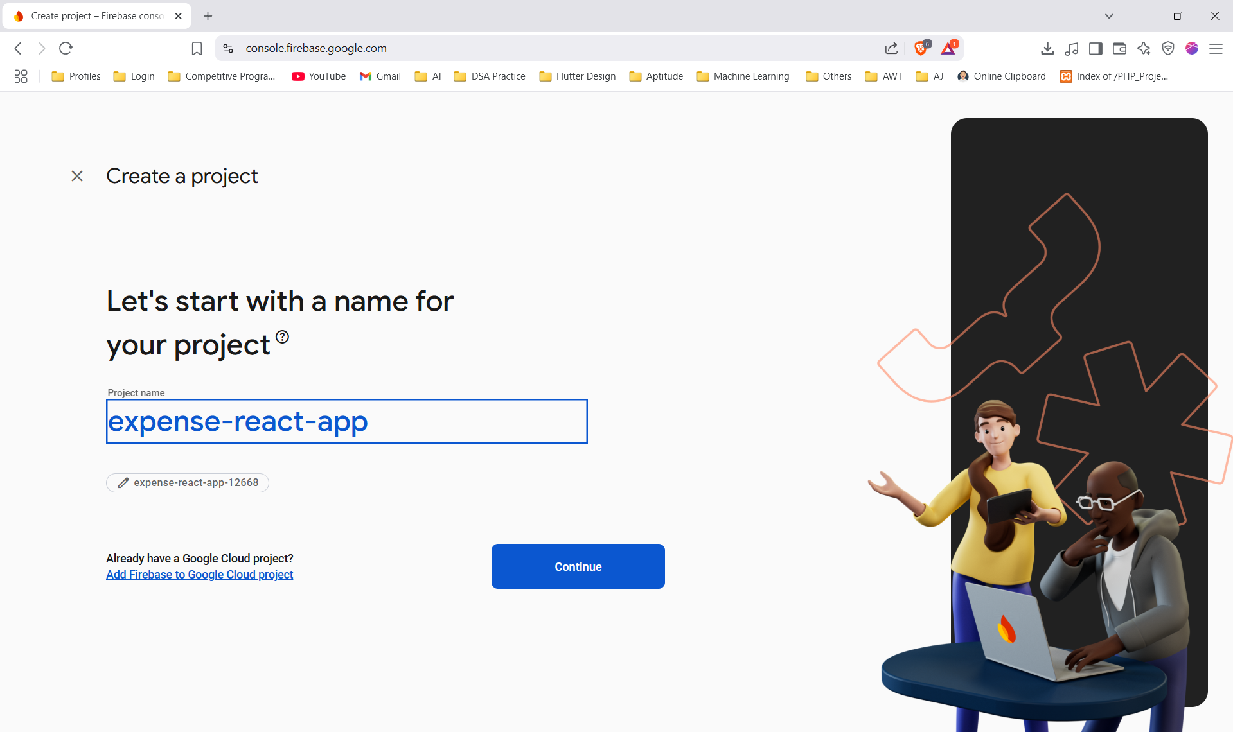**Create a New Firebase Project**
2. **It will take around 2 minutes**

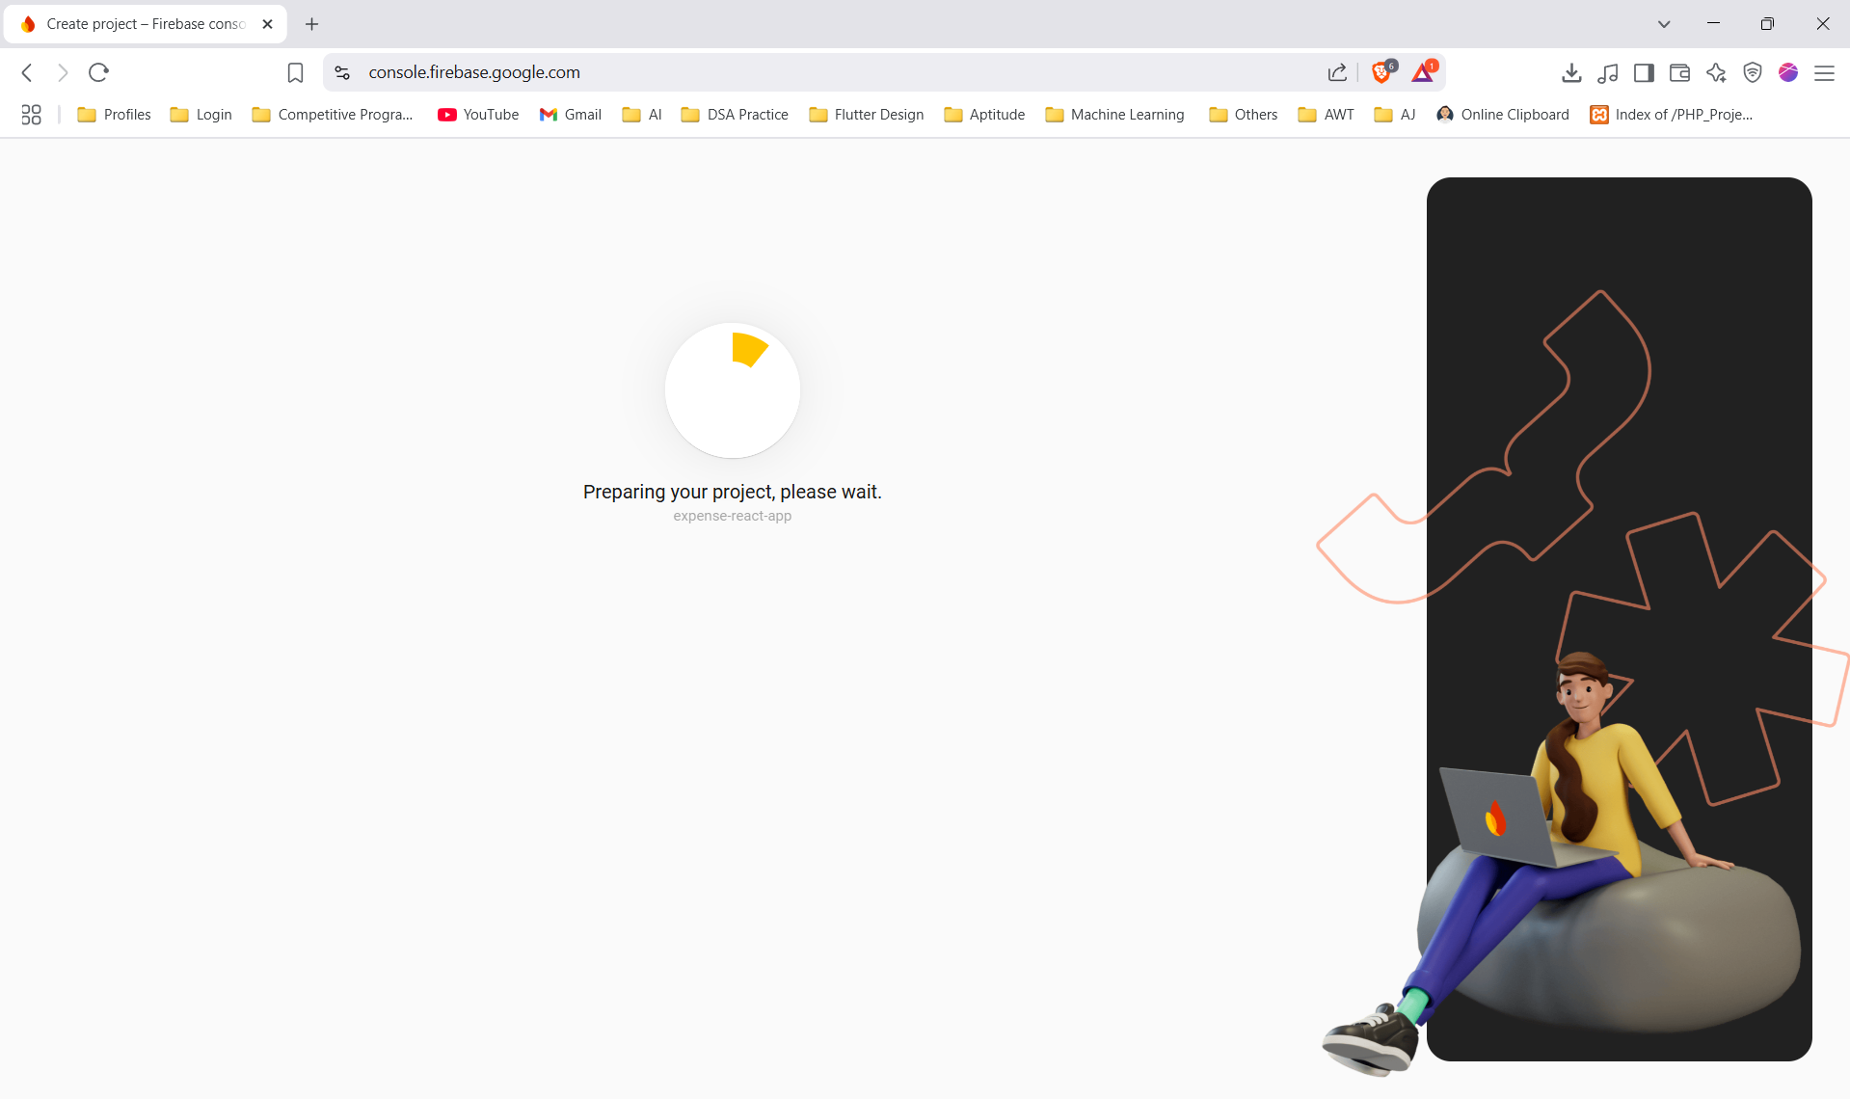

1. **After the Successful Creation of Project you will get this type of Dashboard of Project.**

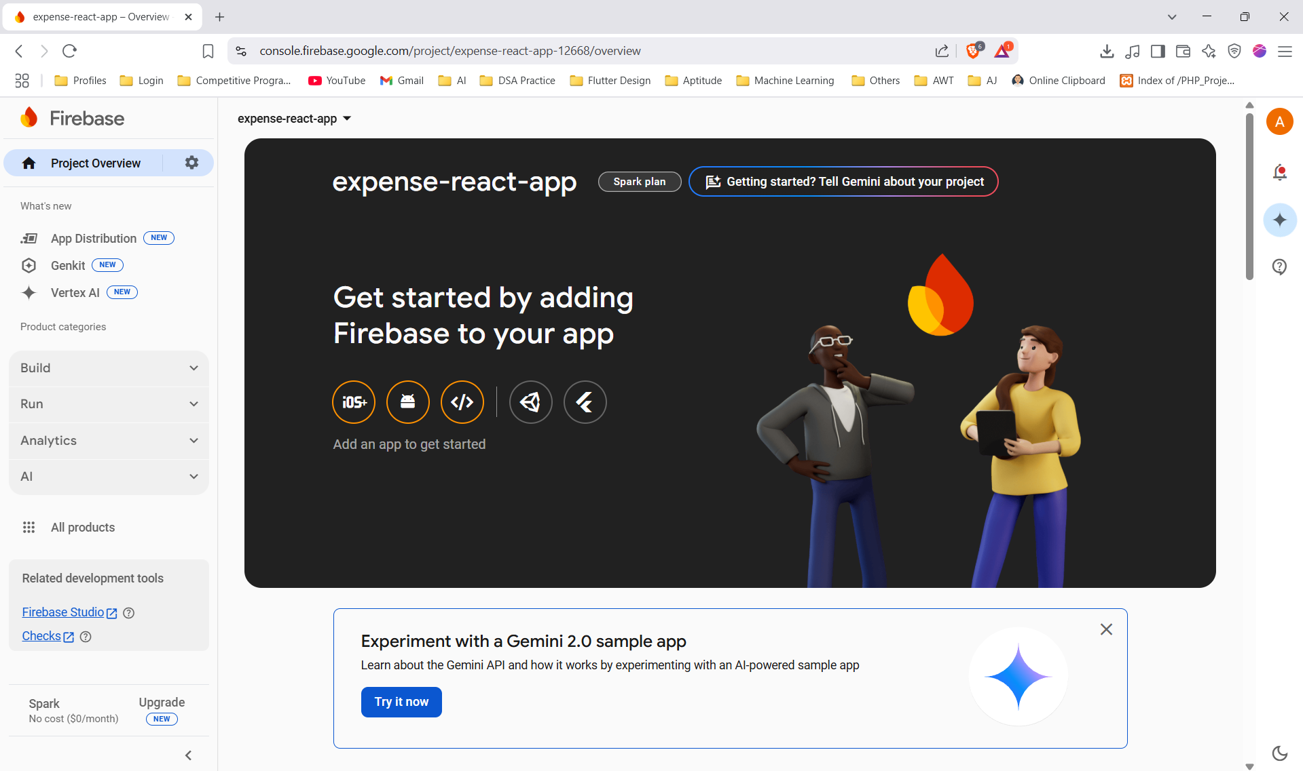

1. **Create a Web app for your project**

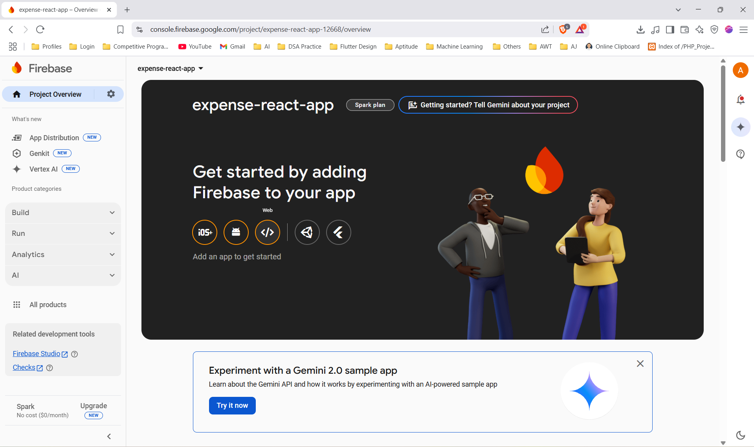

1. **Register Your Web app**

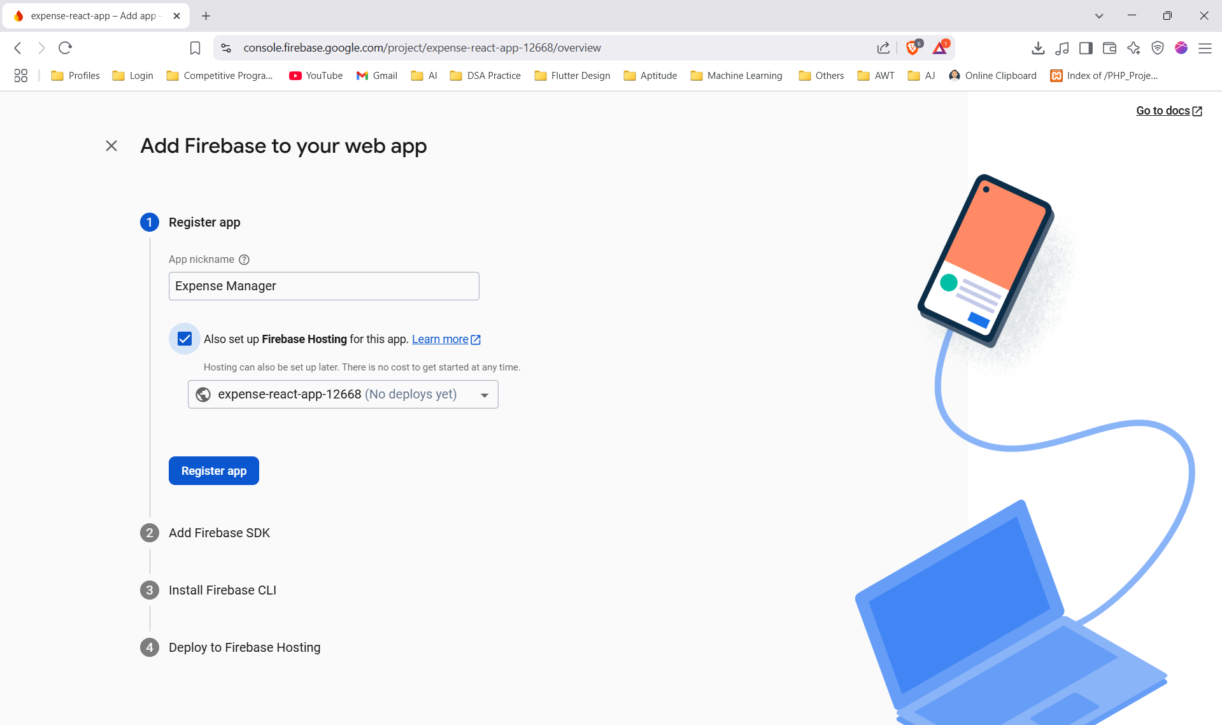

1. 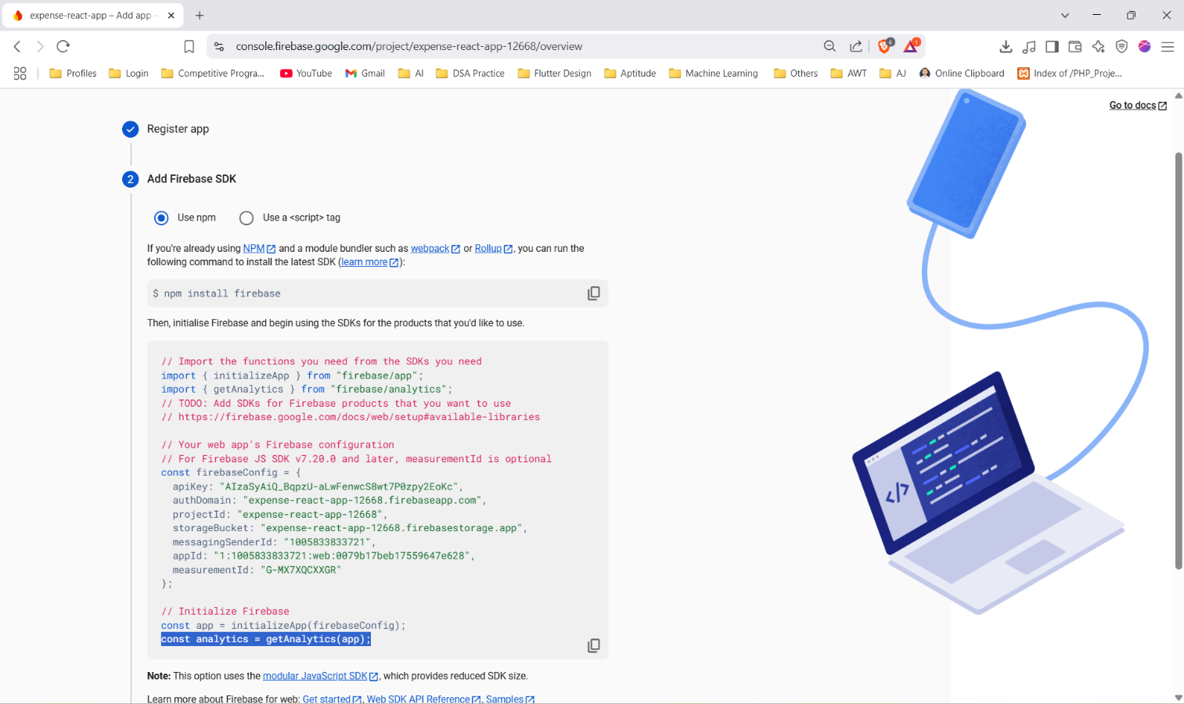**Add Firebase SDK to the Project and Configure the Credentials**

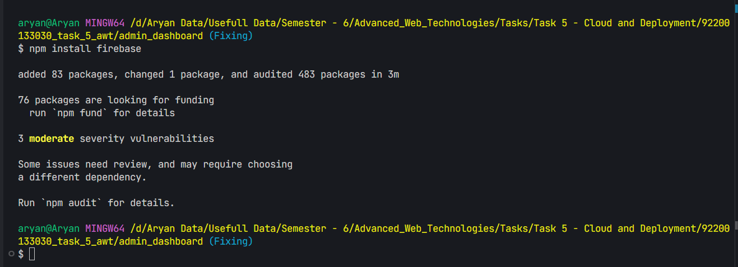

1. **Install Firebase CLI Globally**

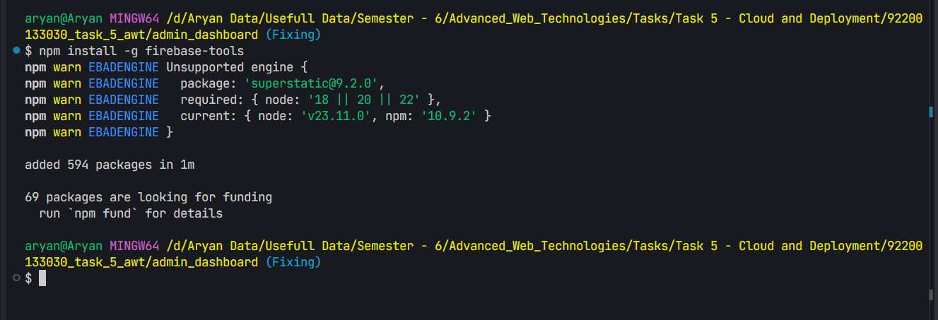

1. **Login through Firebase CLI**

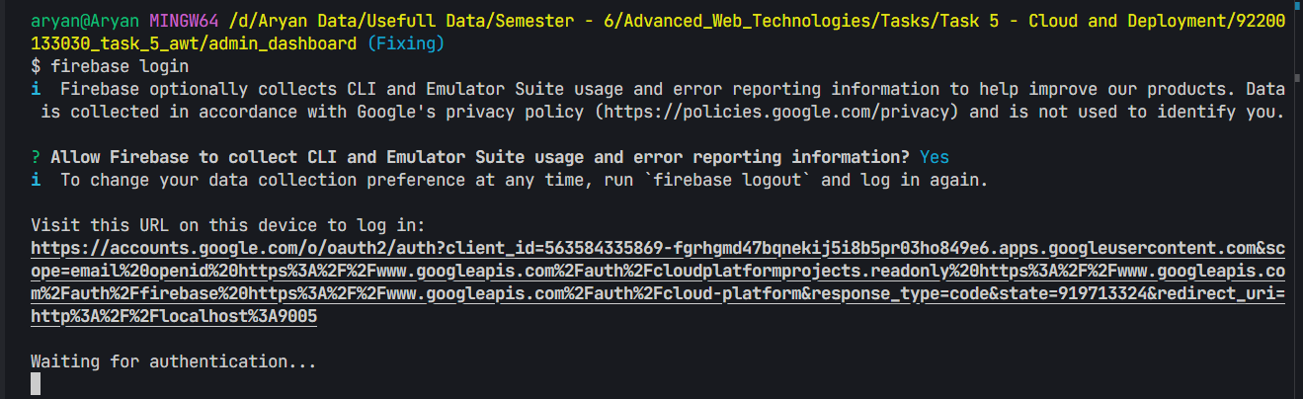

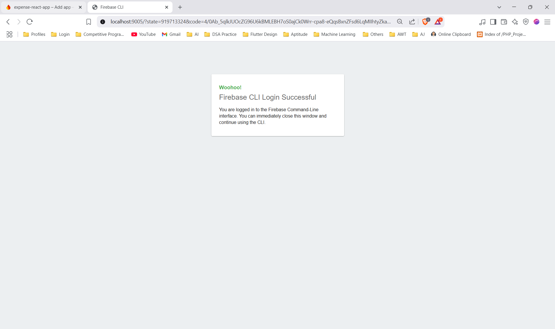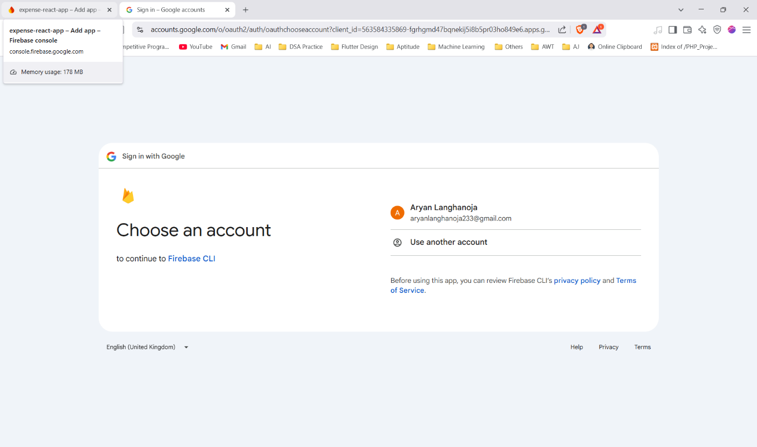

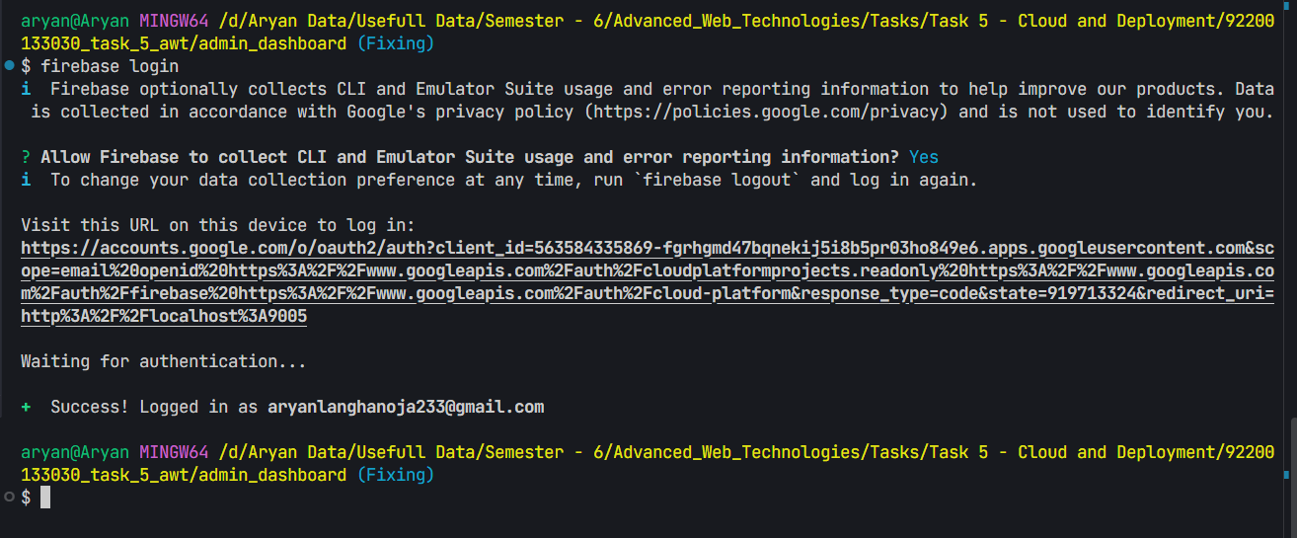

1. **Build Your Website**

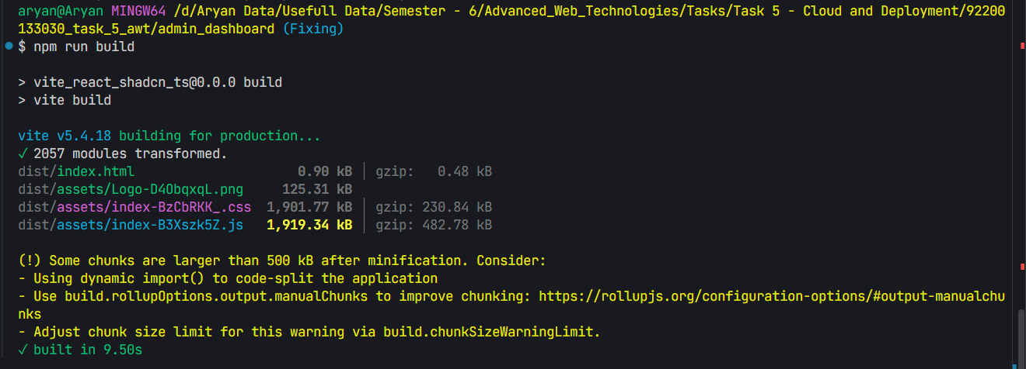

1. **Initialize the Firebase App**

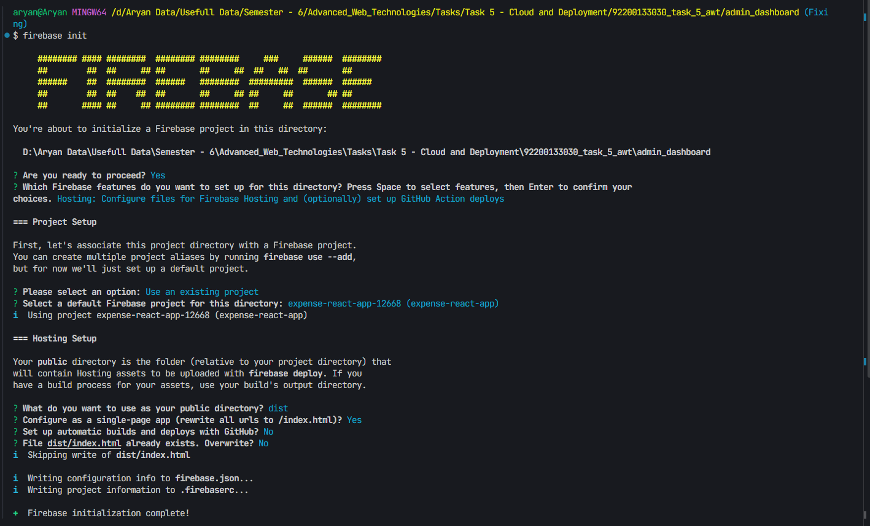

1. **Deploy the App**

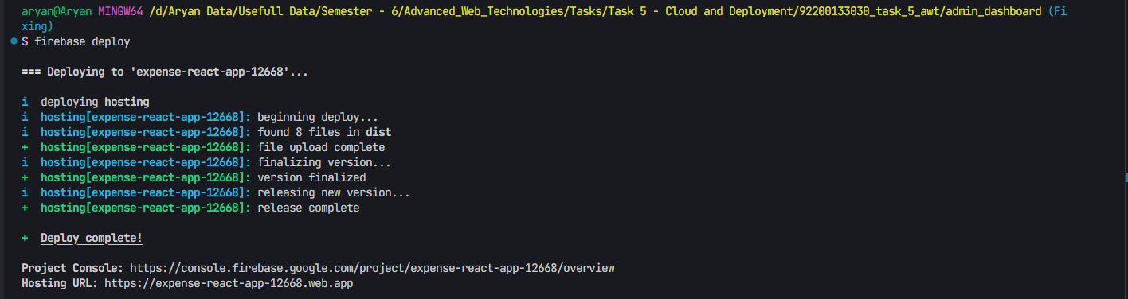

**Live Project Link** **:-** [**https://expense-react-app-12668.web.app**](https://expense-react-app-12668.web.app)